USE CASE SPECIFICATIONS FOR ALL USE CASES IN OUR PROJECT

USE CASE TEMPLATE

|  |  |  |  |
| --- | --- | --- | --- |
| Use Case ID: | IVMPD1.0 | | |
| Use Case  Name: | Meeting Management - Join, Leave, and Create | | |
| Created By: | Anuj Taparia | Last Updated  By: | Ritik Kumar |
| Date Created: | 09-02-24 | Date Last  Updated: | 04-04-24 |

|  |  |
| --- | --- |
| Actors: | * End User |
| Description: | This use case involves the management of virtual meetings by the end user, including joining existing meetings, leaving meetings, and creating new meetings.  These functionalities facilitate user interaction and participation within the virtual meeting platform. |
| Preconditions: | 1. The end user is logged into the virtual meeting platform. 2. The virtual meeting platform is accessible and functional. |
| Postconditions: | The end user successfully joins, leaves, or creates a virtual meeting. |
| **Normal Flow:** | 1. The end user accesses the meeting management interface within the virtual meeting platform. 2. End-user selects the option to join an existing meeting. 3. The platform verifies the end user's credentials and grants access to the selected meeting. 4. End user participates in the ongoing meeting activities. 5. The end user decides to leave the meeting. 6. The end user returns to the meeting management interface. 7. End-user selects the option to create a new meeting. 8. The platform validates the provided information and creates a new meeting. 9. The end user receives confirmation of the successful creation of the meeting. |

|  |  |
| --- | --- |
|  |  |
| **Alternative Flows:** | A1 - If the end user encounters issues while joining a meeting (e.g., invalid credentials), the platform notifies the end user and provides troubleshooting steps.  A2 - If the end user encounters issues while creating a new meeting (e.g., conflicting schedules), the platform prompts the end user to try again. |
| Exceptions: | If the virtual meeting platform experiences technical difficulties, such as server downtime, the platform notifies end users and advises them to try again later or contact support. |
| Includes: | * Joining Existing Meetings * Leaving Meeting * Creating New Meeting |
| Priority: | High |
| Frequency of Use: | Regularly by end users to manage their participation in virtual meetings. |
| Business Rules: | ------ |
| Assumptions: | * End users have stable internet connectivity to access the virtual meeting platform. * The virtual meeting platform supports concurrent meetings and user interactions. |

USE CASE TEMPLATE

|  |  |  |  |
| --- | --- | --- | --- |
| Use Case ID: | IVMPD2.0 | | |
| Use Case  Name: | Manage Meeting Components - Accessibility  Settings | | |
| Created By: | Anuj Taparia | Last Updated  By: | Ritik Kumar |
| Date Created: | 18-02-24 | Date Last  Updated: | 04-04-24 |

|  |  |
| --- | --- |
| Actors: | * End User |
| Description: | This use case involves the capability to manage various meeting components, including configuring accessibility settings, to ensure a well-organized and inclusive virtual meeting for physically disabled individuals. |
| Preconditions: | 1. The user is logged into the virtual meeting platform. 2. The virtual meeting is scheduled or ongoing. |
| Postconditions: | Meeting components, and accessibility settings, are successfully configured, contributing to organized and accessible virtual meetings |
| **Normal Flow:** | 1. End User accesses the meeting management interface. 2. End User configures accessibility settings, such as closed captions and assistive   technologies.   1. End User saves the configured meeting components. (A1) |
| **Alternative Flows:** | A1 - If there is an error in saving the configured meeting components, the platform displays an error message and prompts the Meeting Host to retry. |

|  |  |
| --- | --- |
| Exceptions: |  |
| Includes: | * Real-time ASL Gesture Recognition |
| Priority: | High |
| Frequency of Use: | Frequent, especially by individuals with hearing impairments relying on ASL for communication. |
| Business Rules: | ------ |
| Assumptions: | * The device used by the user has a functional camera and meets the minimum hardware requirements for running the ASL recognition application. * The ASL recognition model deployed in the application has been trained on a diverse dataset of ASL gestures and exhibits satisfactory performance in real-world conditions. * The ASL recognition application provides user-friendly interfaces for gesture input and output translation, ensuring ease of use for individuals with varying levels of technical proficiency. |

USE CASE TEMPLATE

|  |  |  |  |
| --- | --- | --- | --- |
| Use Case ID: | IVMPD3.0 | | |
| Use Case  Name: | ASL Recognition - Recognize User Gestures | | |
| Created By: | Anuj Taparia | Last Updated  By: | Ritik Kumar |
| Date Created: | 18-02-24 | Date Last  Updated: | 04-04-24 |

|  |  |
| --- | --- |
| Actors: | * End User |
| Description: | This use case involves the process of recognizing American Sign Language (ASL) gestures in real time using a trained ASL recognition model. The goal is to provide accessibility and inclusivity for individuals with hearing impairments by enabling them to communicate through ASL gestures, which are translated into text or audio output. |
| Preconditions: | 1. The user has access to a device (e.g., smartphone, tablet, computer) with a camera and the ASL recognition application installed. |
| Postconditions: | The ASL gestures performed by the user are successfully recognized and translated into text. |
| **Normal Flow:** | 1. End User launches the ASL recognition application on their device. 2. The platform activates the device camera to capture ASL gestures performed by the user. 3. End User performs ASL gestures in front of the camera, aiming to express desired messages. 4. The platform processes the captured video feed and applies the trained ASL recognition model to recognize gestures. 5. The ASL recognition model identifies and interprets the ASL gestures in real time. (A1) |
| **Alternative Flows:** | A1 - If the ASL recognition model encounters difficulty in recognizing certain gestures, the platform displays no message. |

|  |  |
| --- | --- |
| Exceptions: |  |
| Includes: | * User Role Assignment * Permission Configuration |
| Priority: | Medium |
| Frequency of Use: | Regularly before and during virtual meetings to ensure  proper access control and collaboration. |
| Business Rules: | User roles and permissions should align with the  responsibilities of individuals within the meeting. |
| Assumptions: | * Meeting Hosts have the necessary permissions to manage user roles and permissions. * The virtual meeting platform supports real-time   updates to user roles and permissions. |

USE CASE TEMPLATE

|  |  |  |  |
| --- | --- | --- | --- |
| Use Case ID: | IVMPD4.0 | | |
| Use Case  Name: | Output as Audio and Text | | |
| Created By: | Anuj Taparia | Last Updated  By: | Ritik Kumar |
| Date Created: | 18-02-24 | Date Last  Updated: | 04-0-24 |

|  |  |
| --- | --- |
| Actors: | - End User |
| Description: | This use case involves the generation of audio output based on the recognized American Sign Language (ASL) gestures. The purpose is to provide an additional communication channel for individuals with hearing impairments, allowing them to convey messages through both visual ASL gestures and auditory cues. |
| Preconditions: | 1. The ASL recognition application is installed and running on the user's device. 2. ASL gestures have been successfully recognized by the ASL recognition model. |
| Postconditions: | Audio output corresponding to the recognized ASL gestures is generated and made available to the user. |
| **Normal Flow:** | 1. End User performs ASL gestures in front of the device camera, and the ASL recognition model accurately recognizes the gestures. 2. The platform receives the recognized ASL gestures from the ASL recognition module. 3. The platform converts the recognized ASL gestures into corresponding audio representations using a predefined mapping or synthesis algorithm. (A1) 4. The generated audio output is played back to the user through the application interface or external speakers/headphones. 5. The End User receives the audio output and interprets the conveyed message in combination with the visual ASL gestures. (A2) |
| **Alternative Flows:** | A1 - If the ASL recognition model fails to recognize certain gestures accurately, the platform displays no message. |

|  |  |
| --- | --- |
|  | A2 - If the audio generation process encounters technical issues or limitations, such as insufficient resources for real-time synthesis, the platform notifies the user and prompts for retry or suggests troubleshooting steps. |
| Exceptions: |  |
| Includes: | * ASL Gesture Recognition Integration * Audio Generation from Recognized Gestures |
| Priority: | Medium |
| Frequency of Use: | Frequent, especially in scenarios where individuals with hearing impairments rely on auditory cues for communication alongside visual ASL gestures. |
| Business Rules: |  |
| Assumptions: | * The ASL recognition application provides seamless integration between gesture recognition and audio generation functionalities, ensuring a cohesive user experience. * The audio generation module employs robust algorithms or synthesis techniques capable of accurately representing ASL gestures in auditory form. * Users have access to compatible audio output devices (e.g., speakers, headphones) to receive the generated audio output effectively. |

# Sequence Diagram of ASL Gesture Recognition

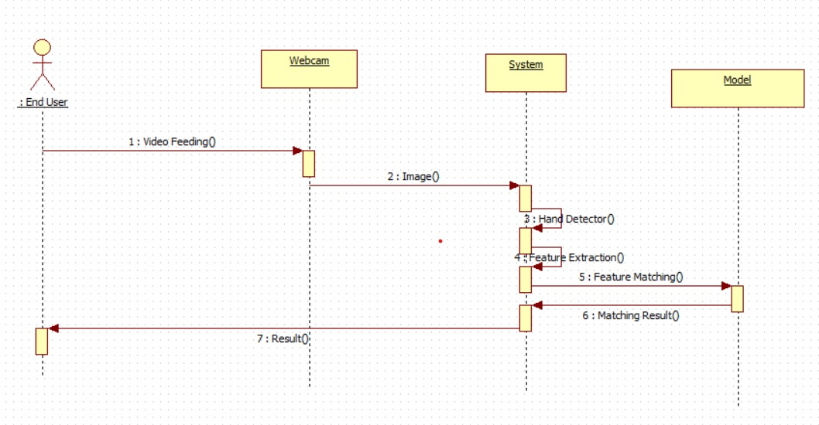

# Use Case Diagram

